Isabella Kelly
Professor Jean Marshall
SOCI 20112 1 (Spring 2026): Applications of Hierarchical Linear Models
15 April 2026
Due April 16, 2026 at 12:00PM

Part A: Two-level Cross-sectional Modeling
1. Obtain a point estimate and standard error for the gap using ordinary least squares regression [you can use the HLM software or any stat package for this part]. Call this the “national gap.”
hsb1 <- read_sav("C:/Users/theis/Downloads/hsb1.sav")
model1 <- lm(MATHACH ~ MINORITY, data = hsb1)
summary(model1)
Call:
lm(formula = MATHACH ~ MINORITY, data = hsb1)
Residuals:
Min 1Q Median 3Q Max
-16.7144 -5.1309 0.3236 5.3351 15.2401
Coefficients:
Estimate Std. Error t value Pr(>|t|)
(Intercept) 13.8824 0.0918 151.22 <2e-16 ***
MINORITY -4.1295 0.1752 -23.58 <2e-16 ***
---
Signif. codes: 0 '***' 0.001 '**' 0.01 '*' 0.05 '.' 0.1 ' ' 1
Residual standard error: 6.627 on 7183 degrees of freedom
Multiple R-squared: 0.07183, Adjusted R-squared: 0.0717
F-statistic: 555.9 on 1 and 7183 DF, p-value: < 2.2e-16

To calculate this regression, I uploaded the hsb1.sav into RStudio. The OLS regression produced a “national gap” estimate of -4.1295. The estimate has a standard error of 0.1752. This means that, on average, minority students are expected to score 4.1295 units lower in math achievement compared to majority students. With a $p_{value}$ of <2e-16 and an $α=0.05$, I conclude that there is statistically significant evidence of a “national gap.”

2. Now estimate the average difference (and standard error) between a minority and a majority student that attend the same school using HLM. Call this the average “within-school gap.” (Hint: centering of the minority indicator correctly is essential to get the right estimate.)
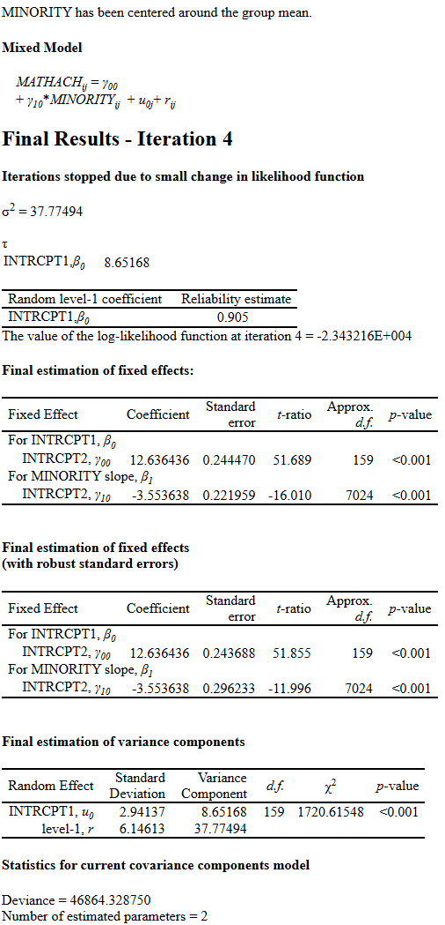

The average “within-school gap” estimated by the model is $γ_{10}$= -3.55368. The estimate has a standard error of 0.296233 (or, without robust standard errors, 0.221959). This means that, when comparing minority and majority students who attend the same school, minority students are expected to score about 3.553628 units lower in math achievement relative majority students. With a $p_{value}$ of <0.001 and an $α=0.05$, I reject $H_{0}$ and conclude that there is statistically significant evidence of a “within-school gap.”

3. Compare the size of the two gaps estimated in (1) and (2). Provide a substantive explanation for why they are different.
The “national gap” estimate in A.1 was -4.1295. The “within-school gap” estimated in A.2 was -3.55368. The “national gap” estimate is ~0.56 units larger than the “within-school gap” because the estimate includes both “within-school” and “between-school” differences. In plain English, the “national gap” considers the possibility that minority students may be more likely to attend lower-achieving schools, and vis versa for majority students. Thus, once I remove the “between-school” differences by estimating only the “within-school gap,” some of the potential interference is removed, and the estimated gap becomes smaller. In even plainer English, the “national gap” is a much broader estimate that reflects student-level and school-level inequality, while the “within-school gap” is narrower because it only compares students attending the same school (as opposed to students across the country attending and wide variety of schools).
4. Consider the extent to which the minority-majority gaps vary from school to school.
4(A): Provide statistical evidence on whether they vary.
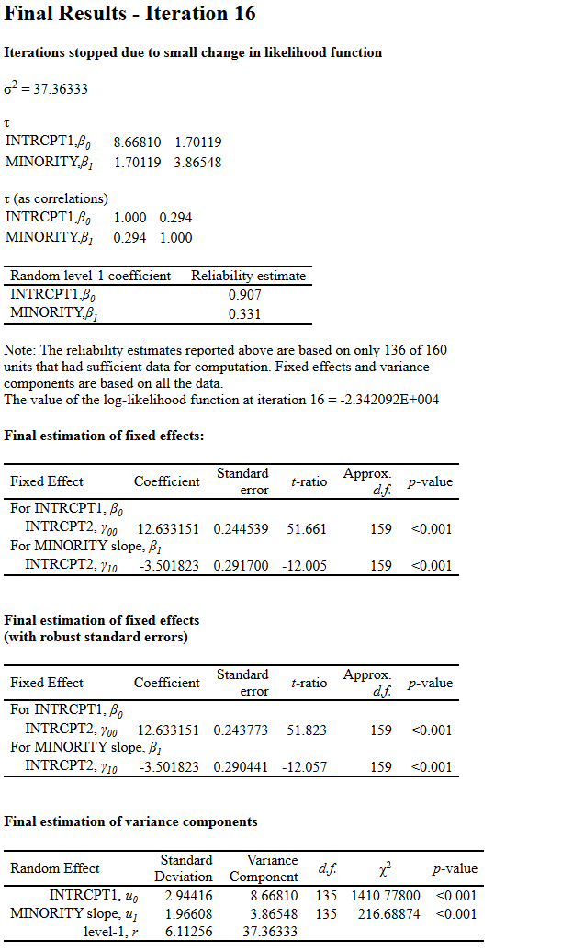
Minority-majority gaps do vary across schools. In the “Final estimation of variance components” table, the “Variance Component” for the minority binary variable is 3.86548. What this number tells us is that some schools have much larger minority-majority gaps relative to others. With a $p_{value}$ of <0.001 and an $α=0.05$, I reject $H_{0}$ that the variance of the minority slope is 0. Therefore, I conclude that there is statistically significant evidence that the size of the minority-majority gap varies from school to school.

4(B): Do schools with higher achievement tend to have higher or lower minority-majority gaps? Provide statistical evidence (you do not need a hypothesis test).
The Iteration 16 results show us that schools with higher math achievement tend to have smaller minority-majority gaps. The covariance between the school intercept and minority estimate is 1.70119; the correlation is 0.294. The covariance estimate suggests that schools with higher math achievement, on average, tend to have binary minority estimates closer to 0. In plain English, higher-achieving schools tend to have smaller minority-majority gaps.
4(C): Provide a graph of the empirical Bayes estimates of the gaps, rank ordered in size and color coded by sector. Is there visual evidence that the size of the gaps varies by sector? Explain.
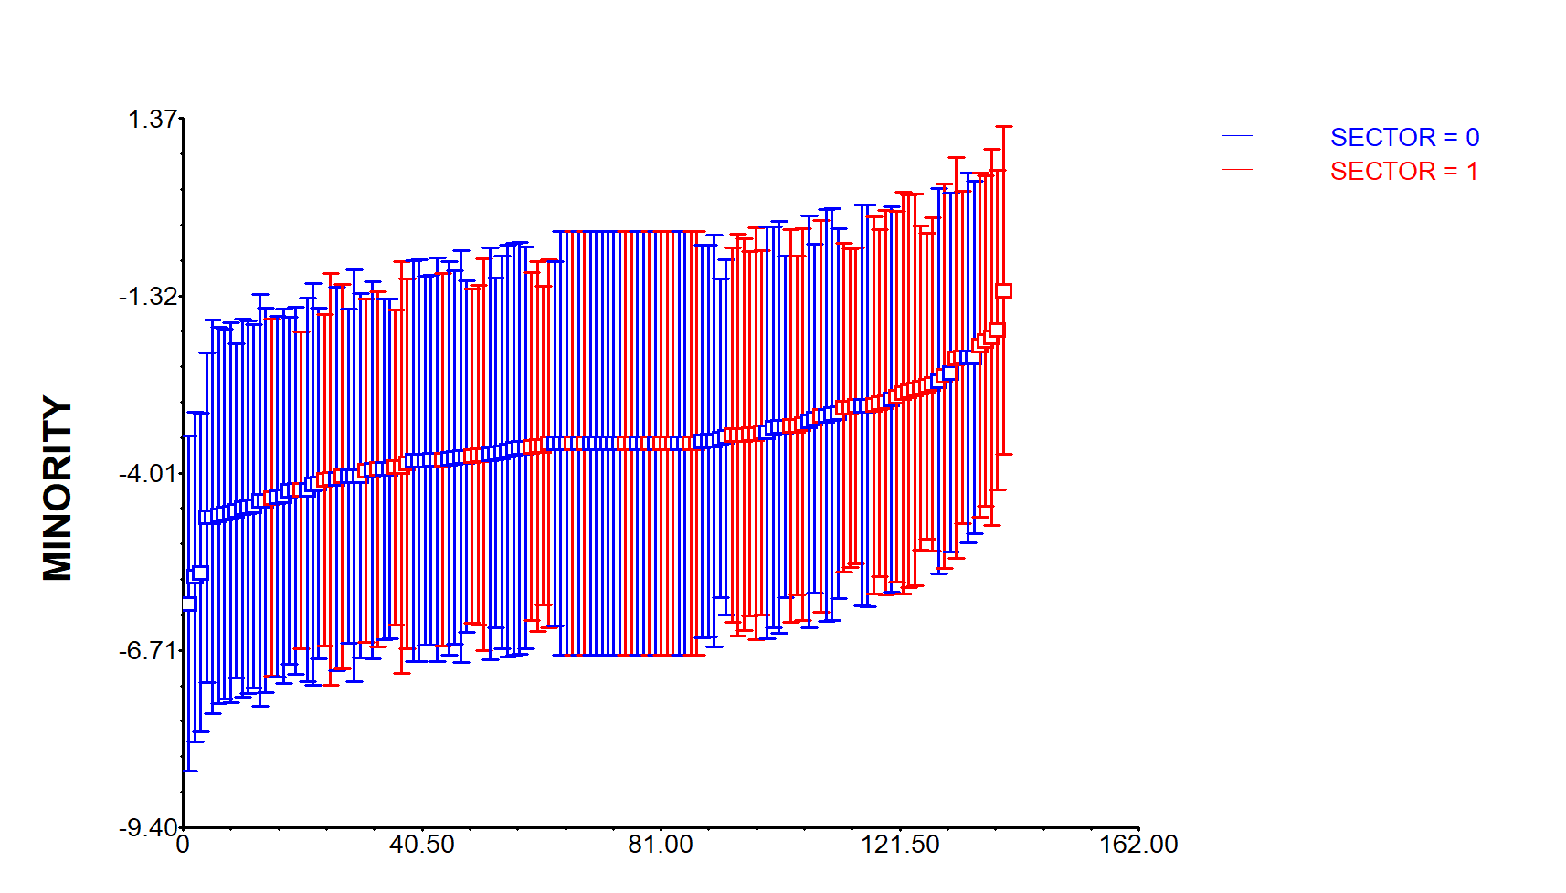
The empirical Bayes graph provides some, but not complete, evidence that the size of minority-majority gap varies by sector. Sector 0 (the blue CIs) represent public schools while Sector 1 (the red CIs) represent Catholic schools. Visually, it can be argued that there is a much greater concentration of public schools among the more negative minority-majority gap estimates, while the opposite is true for Catholic schools; this could suggest that Catholic schools have smaller minority-majority gaps compared to public schools. However, there is a pretty significant overlap between the two types of schools, with red and blue confidence intervals appearing across the range or estimates. This, coupled with the, what can be argued as, large confidence intervals suggests that the graph is suggestive of Catholic schools having smaller gaps, but certainly not conclusive.

5. Add school sector to your model at level 2 for both the intercept and the minority gap coefficient. Provide an estimate of the average minority gap in public schools and in Catholic schools. Provide a hypothesis test that these gaps are the same.

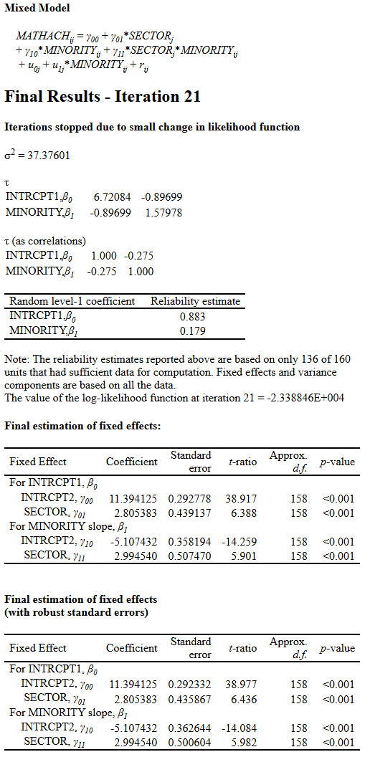
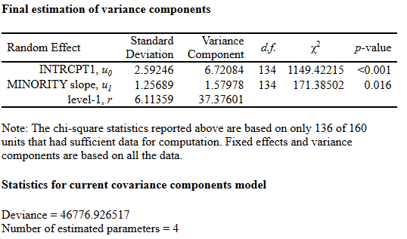
In public schools, the average minority gap is given by the minority slope intercept (as mentioned in A.4, public schools are coded as 0). Thus, the average minority gap in public schools is -5.107432. This estimate suggests that, on average, minority students in public schools are expected to score ~5.11 units lower on math achievement relative to majority students in public schools.
For Catholic schools, the average minority gap is -5.107432 + 2.994540 = -2.112892. This estimate suggests that, on average, minority students in Catholic schools are expected to score ~2.11 units lower on math achievement relative to majority students in Catholic schools.
To test my hypothesis, I will specifically look at the $p_{value}$ of the $γ_{11}$ estimate. With a $p_{value}$ of <0.001 and an $α=0.05$, I reject $H_{0}$ that there is no difference in the minority-majority gap between public and Catholic schools. Therefore, I conclude that the minority-majority gap is statistically significantly different between public and Catholic schools.
6. It is reasonable to suggest that the minority gaps might depend on the racial makeup of the school. The indicator variable HIMINTY is coded 1 if minority enrollment in a school exceeds 40%. Add this indicator to your model along with sector for both level 1 terms.

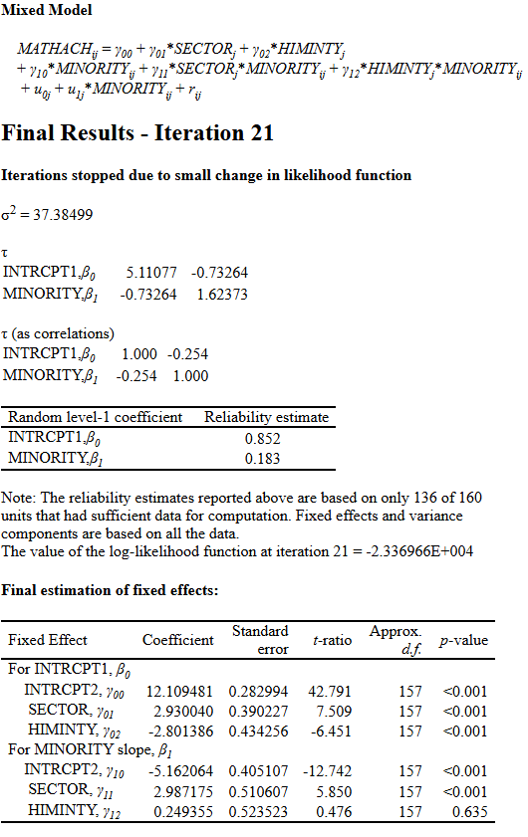
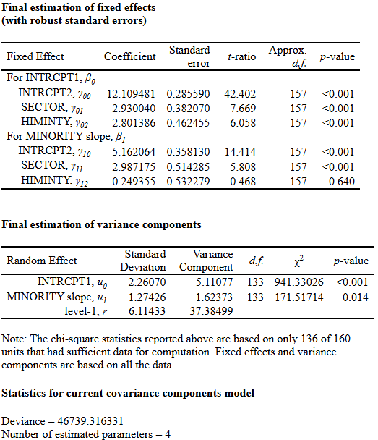
6(A): Interpret the coefficients for the new HIMINITY terms reported by your model
- The HIMINTY, $γ_{02}$ estimate is -2.801386. This estimate shows us the difference in average math achievement scores between schools where minority enrollment exceeds 40%, and schools where minority enrollment does not exceed 40%. This means that, holding constant school sector, I expect that schools with minority enrollment above 40% will have math achievement scores that are ~2.80 units low than schools with minority enrollment below 40%. With a $p_{value}$ of <0.001 and an $α=0.05$, I reject $H_{0}$ that $γ_{02}=0$.
- The HIMINTY, $γ_{12}$ estimate is 0.249355. This estimate means that in schools where minority enrollment is above 40%, the minority-majority gap is predicted to be 0.25 points smaller than in schools where minority enrollment is below 40%, holding constant school sector. However, with a $p_{value}$ of 0.640 and an $α=0.05$, I fail reject $H_{0}$ that $γ_{12}=0$ and cannot conclude that the minority-majority gap differs by school minority composition.
6(B): How does adding racial makeup to the model change our understanding of how school sector affects math achievement? Explain
Before adding the racial makeup to the model, the $γ_{01}=2.805383$. This estimate shows us the difference in average math achievement between Catholic and public schools. In other words, Catholic schools were predicted to score ~2.81 units higher than public schools on average. However, after adding the racial makeup to the model, the coefficient increased to 2.930040. This means that Catholic schools still had higher average math achievement even after controlling for whether minority enrollment exceeded 40%. The $γ_{11}=2.994540$ estimate increased to 2.987175 after adding racial makeup to the model. This estimate suggests that the minority-majority gap is ~2.99 units less negative in Catholic schools compared to public schools. If anything, adding the racial makeup only confirmed the evidence suggesting that Catholic schools have higher math achievement and smaller minority-majority gaps than public schools, on average, even after including whether the school has a minority enrollment of above 40%.
7: Write a summary paragraph explaining what you have learned about the minority majority math achievement gap in the US in 1980.
The regressions above suggest that there was a clear minority-majority math achievement gap between White students and Black/Hispanic students in 1980. Across the country (e.g. across all schools), minority students scored an average of 4.13 units lower than White students, on average. Within the same school, minority students scored an average of 3.57 units lower than White students, on average; this shows that perhaps part of the national gap can be explained by the school a student attends. Furthermore, the data revealed that higher-achieving schools and Catholic schools tend to have smaller minority-majority gaps. Overall, the regressions suggest that, in 1980, the minority-majority math achievement gap varied across schools and was smaller in Catholic schools than public schools; but across all estimates, minority students were expected to score lower than majority students, on average.

Part B. Two-level Growth modeling
1: Write down a level-1 model that includes a linear and quadratic growth terms. For this model, age should be centered around 18 months. Define each π and eti.
${VOCAB}_{ti}= π_{0i}+ π_{1i}*\left({AGE18}_{ti}\right)+ π_{2i}*\left({AGE18SE}_{ti}\right)+e_{ti}$
$π_{0i}$ shows the predicted vocabulary size for child_{i} at 18 months.
$π_{1i}$ shows the linear vocabulary growth-rate for child_{i} at 18 months.
$π_{2i}$ shows the quadratic vocabulary growth-rate for child_{i}.
$e_{ti}$ shows the Level-1 error term and represents the difference between child_{i}’s actual vocabulary at time t and their predicted vocabulary from the model.

2: Write down a level-2 model in which each level 1 term is allowed to vary randomly. Define each each β and each r
$$π_{0i}=β_{00}+r_{0i}$$
$$π_{1i}=β_{10}+r_{1i}$$
$$π_{2i}=β_{20}+r_{2i}$$
$β_{00}$ shows the average vocabulary size across all children at 18 months.
$β_{10}$ shows the average linear growth rate in vocabulary at 18 months across all children.
$β_{20}$ shows the quadratic linear growth rate in vocabulary at 18 months across all children.
$r_{0i}$ shows child_{i}’s deviation from the overall average vocabulary size at 18 months.
$r_{1i}$ shows child_{i}’s deviation from the average linear growth rate in vocabulary at 18 months across all children.
$r_{2i}$ shows child_{i}’s deviation from the average quadratic vocabulary growth-rate across all children.

3: Run the model using Full Maximum Likelihood estimation. Explain in substantive terms what your estimates for each beta means for the shape of your estimated growth trajectories
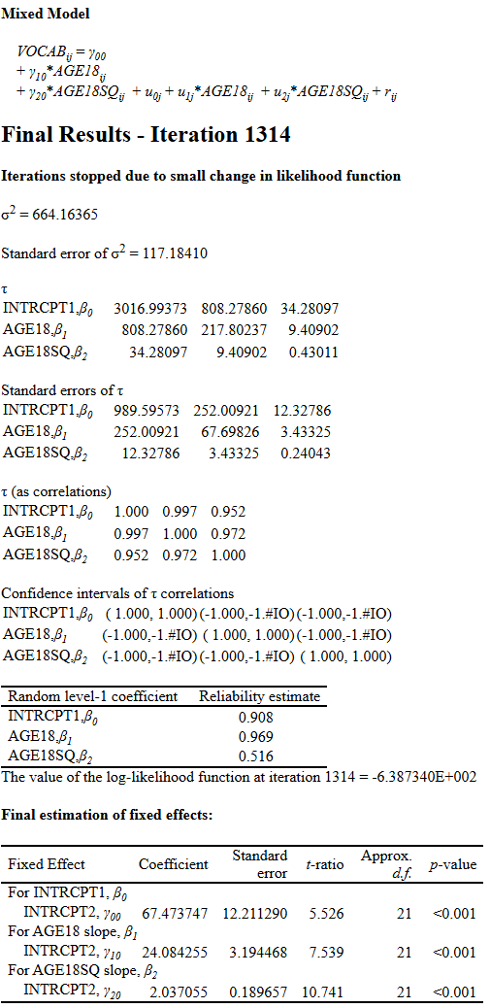
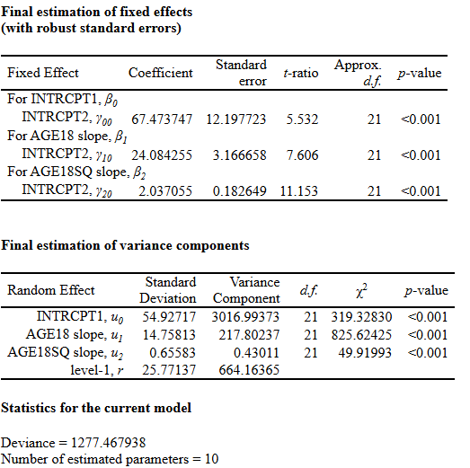
The estimate for $β_{0}$ is 67.473747. This suggests that the average child is expected to have a vocabulary of ~67 words at 18 months.
$$H_{0}: β_{0}=0$$
$$H_{A}: β_{0}≠0$$
$$α=0.05$$
With a $p_{value}$ of < 0.0001 and an $α$ = 0.05, I reject $H_{0}$ that $β_{0}$ equals 0. This means the predicted average vocabulary at 18 months is statistically different from 0.

The estimate for $β_{1}$ is 24.084255. This suggests that children are expected to gain about 24.08 words per month.
$$H_{0}: β_{1}=0$$
$$H_{A}: β_{1}≠0$$
$$α=0.05$$
With a $p_{value}$ of < 0.0001 and an $α$ = 0.05, I reject $H_{0}$ that $β_{1}$ equals 0. This means the average linear vocabulary growth rate at 18 months is statistically different from 0.

The estimate for $β_{2}$ is 2.037055. This suggests a child’s vocabulary growth is not only increasing linearly over time, but increasing at a faster rate as they get older.
$$H_{0}: β_{2}=0$$
$$H_{A}: β_{2}≠0$$
$$α=0.05$$
With a $p_{value}$ of < 0.0001 and an $α$ = 0.05, I reject $H_{0}$ that $β_{2}$ equals 0. This means the average quadratic vocabulary growth is statistically different from 0.

4: Add the measure of words spoken by the mother at the 16-month observation
(MOMSPEAK) to the model at level 2 for each level 1 term. Define $β_{00}$, $β_{01}$, $β_{10}$, and $β_{11}$.
$$π_{0i}=β_{00}+β_{01}(MOMSPEAK_{i})+r_{0i}$$

$$π_{1i}=β_{10}+β_{11}(MOMSPEAK_{i})+r_{1i}$$
$$π_{2i}=β_{20}+β_{21}(MOMSPEAK_{i})+r_{2i}$$
$β_{00}$ shows the estimated vocabulary size at 18 months for a child whose mother spoke 0 words at the 16-month observation.
$β_{01}$ shows the expected change in vocabulary size at 18 months for each additional word spoken by the mother at the 16-month observation.
$β_{10}$ shows the estimated linear vocabulary growth rate at 18 months for a child whose mother spoke 0 words at the 16-month observation.
$β_{11}$ shows the expected change in the linear vocabulary growth rate at 18 months for each additional word spoken by the mother at the 16-month observation.

5: Run the model with MOMSPEAK and explain in a paragraph what you found

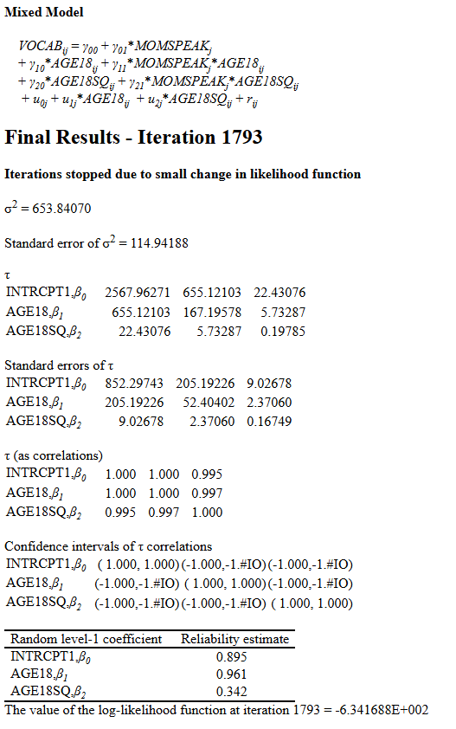
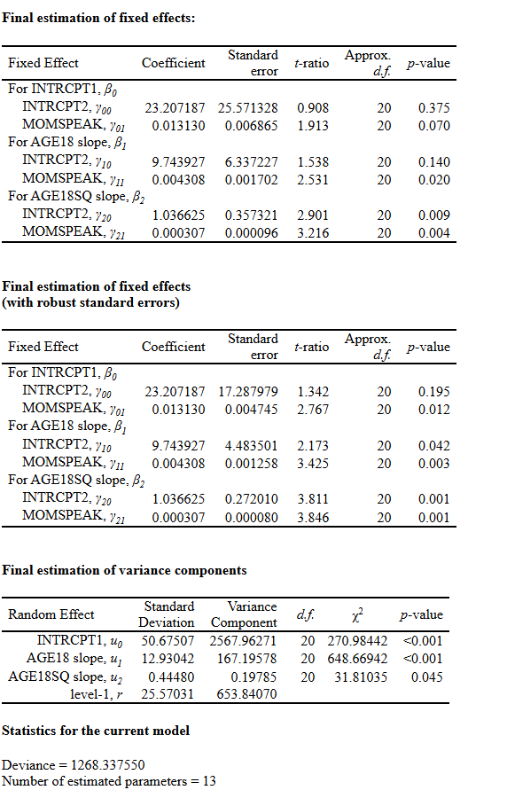

The regression suggests that the number of words spoken by the mother at the 16-month observation is positively associated with their child’s vocabulary. The $γ_{01}$ estimate is 0.013130; this estimate suggests that children whose mothers spoke words at the 16-month observation were expected to have a larger vocabulary at 18-months (specifically: 23.207187 + 0.013130 = 23.220317 words. The $γ_{11}$ estimate is 0.004308. This estimates that the number of words spoken by the mother at the 16-month observation is associated with a faster vocabulary growth-rate at 18 months. The $γ_{21}$ estimate is 0.000307. This estimate suggests that the number of words spoken by the mother at the 16-month observation is association with a faster vocab growth-rate over time. Together, the findings suggest that children whose mothers spoke more words at 16 months are expected to have higher vocabulary levels and faster vocabulary growth at 18 months, on average.
6: Create a model graph to visualize the results of the final model, showing the model-based trajectories for children whose mothers are at the 25th and 75th percentiles of MOMSPEAK.
